**Project Design Phase-II(Requirement analysis)**

**Data Flow Diagram & User Stories**

|  |  |
| --- | --- |
| Date | 15 june 2025 |
| Team ID | LTVIP2025TMID46308 |
| Project Name | Doc Spot |
| Maximum Marks | 4 Marks |

**Data Flow Diagrams:**

The **Data Flow Diagram (DFD)** for **DocSpot** represents the movement of data across various components of the system. It visualizes how information flows between **external entities** (patients, doctors, admins) and **internal processes** such as authentication, appointment handling, and system management.

This structured flow ensures efficient communication between modules while maintaining data integrity and security.

**👥 Actors Involved**

1. **Patients**
   * Register and log into the platform
   * Search and view doctor profiles
   * Book and manage appointments
2. **Doctors**
   * Register and log in for access
   * Set their availability and profile details
   * View and respond to appointment requests
3. **Administrators**
   * Approve or reject doctor registrations
   * Manage users and monitor appointments
   * Oversee system-wide activities

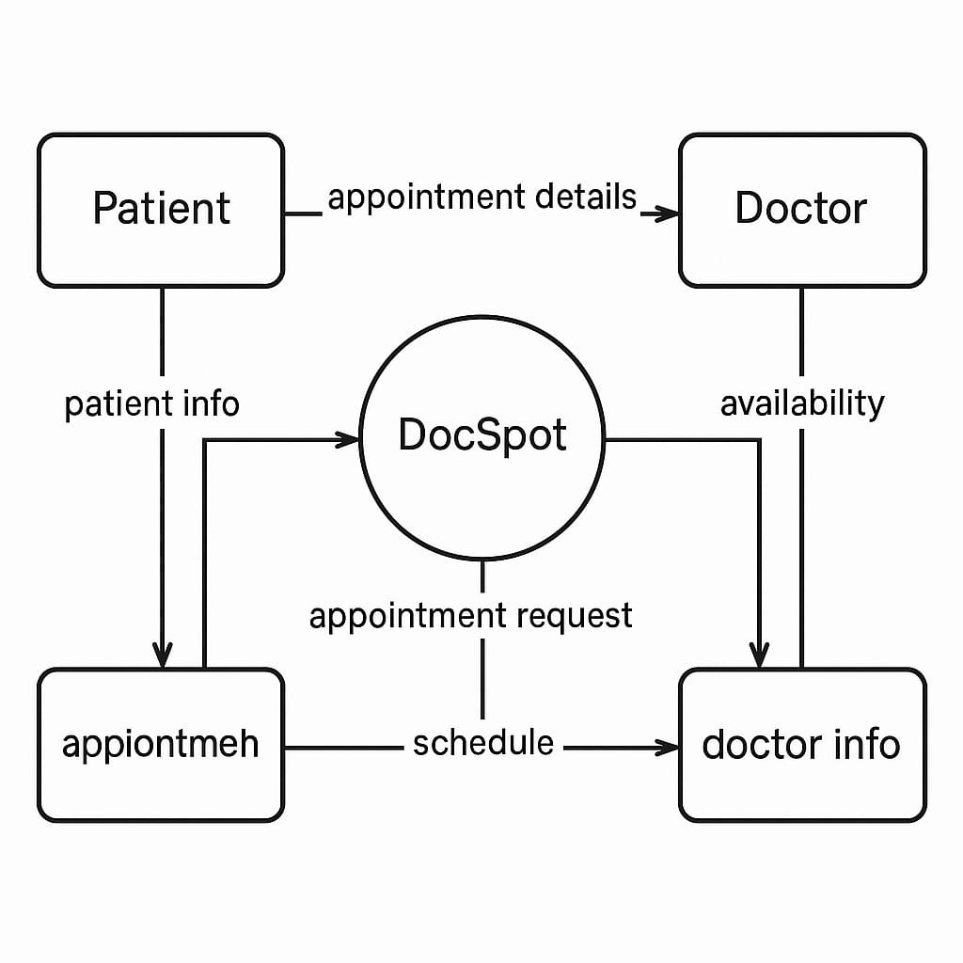**DATA-FLOW DIAGRAM:**

**User Stories**

Use the below template to list all the user stories for the product.

| **User Type** | **Functional Requirement (Epic)** | **User Story ID** | **User Story / Task** | **Acceptance Criteria** | **Priority** | **Release (Sprint)** |
| --- | --- | --- | --- | --- | --- | --- |
| **Customer (Mobile)** | Registration | USN-1 | As a user, I want to register using my email, password, and confirm password. | User is able to register and access the dashboard after successful validation. | High | Sprint-1 |
| **Customer (Mobile)** | Registration | USN-2 | As a user, I want to receive a confirmation email after successful registration. | Confirmation email is sent, and account is activated upon clicking the confirmation link. | High | Sprint-1 |
| **Customer (Mobile)** | Registration | USN-3 | As a user, I want to register using my Facebook account. | User can sign in via Facebook and reach the dashboard without issues. | Low | Sprint-2 |
| **Customer (Mobile)** | Registration | USN-4 | As a user, I want to register or log in using my Gmail account. | User can authenticate with Gmail and be redirected to the dashboard. | Medium | Sprint-1 |
| **Customer (Mobile)** | Login | USN-5 | As a user, I want to log in using my registered email and password. | After successful login, the user is redirected to their personalized dashboard. | High | Sprint-1 |
| **Customer (Mobile)** | Dashboard | USN-6 | As a user, I want to view my upcoming appointments and notifications. | Dashboard displays a list of upcoming appointments and relevant health alerts. | High | Sprint-2 |
| **Customer (Mobile)** | Appointment Booking | USN-7 | As a user, I want to search for doctors and book an appointment. | Booking confirmation is shown with doctor details, time, and date. | High | Sprint-2 |
| **Customer (Web)** | Dashboard | USN-8 | As a user, I want to access my dashboard from a web browser to view appointment history. | Dashboard is accessible from browser with appointment history and status. | High | Sprint-2 |
| **Customer Care Executive** | Profile Settings | USN-9 | As a user, I want to edit my profile information such as name, gender, and phone. | Profile updates are saved and reflected instantly. | Medium | Sprint-3 |
| **Administrator** | Appointment Management | USN-10 | As an admin, I want to view all upcoming appointments made by users. | A sortable/filterable list of upcoming appointments is visible. | Medium | Sprint-3 |
| **Administrator** | Patient Communication | USN-11 | As an admin, I want to contact patients for confirmations or follow-ups. | Communication options (email, SMS, call) are accessible from admin dashboard. | Medium | Sprint-4 |
| **Administrator** | Doctor Management | USN-12 | As an admin, I want to approve or reject doctor applications. | Doctor status is updated with an appropriate notification sent to the doctor. | High | Sprint-3 |
| **Administrator** | System Analytics | USN-13 | As an admin, I want to view metrics like total users, doctors, and appointments. | Dashboard displays real-time statistics with charts and metrics. | Medium | Sprint-4 |